
TERM-1
FIRST TERM EXAM (2023-24)
SET-1 (Answer key)
Subject: GEOGRAPHY  Grade: XII |  | Max. Marks: 70  Time: 3 Hours
SECTION A
(OBJECTIVE TYPE QUESTIONS)
1 | (a) NCT Delhi |  | 1
2 | (a) stagnant or stationery phase of growth of India’s population. |  | 1
3. | (b) helmeted settlement |  | 1
4. | (c) religious towns |  | 1
5 | (d) Tamil Nādu |  | 1

6 | Options: (a)i, iv, iii, ii |  | 1
7 | (b) The Brahmaputra |  | 1
8 | (a) Irrigation |  | 1
9 | (d) Poverty |  | 1
10 | (a) 2014 |  | 1
11. | (d) All of the Above |  | 1
12. | (a) Dr. Mahbub-ul-Haq |  | 1
13 | (c )Poverty index |  | 1
14. | (c) above 0.8 |  | 1
15. | (a)Norway |  | 1
16. | (c)Wheat |  | 1
17. | (c)Marginal Land |  | 1

SECTION B
SOURCE BASED QUESTION
18.1 | The growth of population expressed in percentage |  | 1
18.2 | Natural Growth of population is the increased by the difference between births and deaths in a particular region between two points of time. |  | 1
18.3 | The annual growth rate of India as per 2011 Census 1.64 percent |  | 1
19.1 | . Dharavi is located in Mumbai |  | 1
19.2 | The place Dharavi been compared the industrial dwelling of Victorian London’s East |  | 1
19.3 | According to the passage, earlier Dharavi was a/an was an arm of the sea |  | 1
SECTION C
SHORT ANSWERS
20. | a)Water gets polluted by foreign matters such as microorganisms, chemicals, industrial and other wastes. Such matters deteriorate the quality of water and render it unfit for human use.  b)When toxic substances enter lakes, streams, rivers, ocean and other water bodies, they get dissolved or lie suspended in water.  c)This results in pollution of water whereby quality of water deteriorates affecting aquatic systems. Sometimes, these pollutants also seep down and pollute groundwater. |  | 3
21. | Ans These are the resources which can be used by all members of the community like - CommunityHall,Pastures,ruralwater area etc. No member of the communityhas ownership on any part of these resources. All the members can only not use these resources but they have certain duties to save and protect their resources |  | 3
22. | These towns have developed in mineral rich areas such as Raniganj, Jharia, Digboi,Singrauli |  | 3
23. | The physical factors are concerned, it is clear that climate along with terrain and availability of water largely determines the pattern of the population distribution. Consequently, the North Indian Plains, deltas and Coastal Plains have higher proportion of population than the interior districts of southern and central Indian States, Himalayas, some of the north eastern and the western states. However, development of irrigation (Rajasthan), availability of mineral and energy resources (Jharkhand) and development of transport network (Peninsular States) have resulted in moderate to high concentration of population in are.as which were previously very thinly populated. |  | 3
SECTION D
LONG ANSWERS
24. | Demand of Water for Irrigation –  In agriculture, water is mainly used for irrigation.  Irrigation is needed because of spatio-temporal variability in rainfall in the country .  The large tracts of the country are deficient in rainfall and are drought prone. Eg. North-western India and Deccan plateau Water requirement of rice, sugarcane, jute, etc. is very high which can be met only through irrigation.  Neeru-Meeru (Water and You) programme (in Andhra Pradesh) and Arvary Pani Sansd (in Alwar, Rajasthan) are the water conservation projects of Andhra Pradesh and Rajasthan. |  | 3+2
25.1 | a. The income approach: This is one of the oldest approaches. Human development is linked to income. The idea is that the level of income reflects the level of freedom an individual enjoys. Higher the level of income, the higher is the level of human development.  b. The welfare approach: Human development is linked to government expenditure on welfare. The idea is that the level of expenditure reflects the level human development. Higher the level government expenditure on welfare, the higher is the level of human development.  c. Minimum needs approach: This approach was initially proposed by the International  Labour Organisation (ILO). Six basic needs i.e.: health, education, food, water supply, sanitation, and housing were identified. Higher the provision on basic needs, the higher is the level of human development.  d. Capabilities approach: This approach is associated with Prof. Amartya Sen. Building human capabilities in the areas of health, education and access to resources is the key to increasing human development. |  | 5
 | OR
25.2 | The basic goal of development is to create conditions where people can live meaningful lives.  The four pillars of human development- Equity-It refers to providing equal access to opportunities available to everybody irrespective of their gender, race, income and caste. Sustainabillty- Sustainabillty means continuity in the availability of opportunities for sustainablehuman development. Productivity - It refers to human labour productivity in terms of human work. It must be constantly enriched by building capabilities in people. Empowerment- It means to have the power to make choices. Such power comes from increasing freedom and capabilities, good governance and people -ori• ented policies, so as to empower people. |  | 1+4
26. | The growth of population is the change in the number of people living in a particular area between two points of time. Its rate is expressed in percentage. It can be + ve or – ve.  - States like Bihar and Sikkim have a very high percentage of rural population.  - Whereas the states of Goa and Maharashtra have low per cent of rural population.  - The Union Territories have a smaller proportion of the rural population.  - Dadra and Nagar Haveli have a high proportion of rural population (77.1 per cent).  - In the hilly states, Western Rajasthan, and Rann of Kachchh in Gujarat the size of villages is less than 200 persons.  - In the states of Kerala and Maharashtra the size of villages is 17 thousand persons.  - These variations at intra-State and inter-State levels are due to variations in degree of urbanization and extent of rural-urban migration. |  | 1+4
 | OR
26.2 | The growth of population is the change in the number of people living in a particular area between two points of time. Its rate is expressed in percentage. It can be + ve or – ve.  The four language families are.  - Austric (Nishada) ,Dravidian (Dravida) ,Sino-Tibetan (Kirata) ,Indo –European (Aryan)  Four states in which this language is spoken are :  a) Jammu & Kashmir, b) Punjab, c) Himachal Pradesh, d) U.P., e) Rajasthan, f) Haryana  Among the four families Indo-European (Aryan) are spoken largest in India. |  | 1+3+1
27. | Clustered, agglomerated and nucleated settlement: - a. In this type of settlement, the built-up area is compact and inter-house distance is small.  b. In this type of village the general living area is distinct and separated from the surrounding farms.  c. Such settlements are found in highly productive alluvial plains (Punjab), in the valleys of Shiwaliks (Dehradun) and in north eastern states.  2. Semi-clustered settlements: - a. In this type of settlement, the built-up area is less compact as compared to the clustered settlement.  b. It may result from segregation or fragmentation of a large compact village.  c. Some sections of a village society choose or is forced to live a little away from the main cluster or village.  e. Such settlements are found in Gujarat plain and parts of Rajasthan.  3. Hamleted settlement: -  a. When a large settlement gets fragmented into several smaller units physically separated from each other but bears a common name it forms hamleted settlement.  b. It occurs due to social and ethnic factors.  c. These small units of settlements are known as panna, para, palli, nagla, dhani etc.  d. Such settlements are found in the Ganga plains, lower valleys of Himalayas.  4. Dispersed settlement: -  a. When a settlement has a few isolated huts it is called dispersed settlement.  b. These types of settlements are found in remote jungles, small hills with a few farms and pastures on the slope.  c. It results from extremely fragmented and small resource support.  d. They are found in Meghalaya, Uttaranchal, Himachal Pradesh and Kerala |  | 5
28 | The problems associated with urban wastes in metropolitan cities of India are:  a. Most of solid wastes in metropolitan cities are left uncollected. For example in small cities and towns about 30-50% of the solid wastes is uncollected.  b. This uncollected waste accumulates on streets, in open spaces between houses and in wastelands leading to serious health hazards.  c. Untreated wastes ferment slowly and release toxic biogas to the atmosphere, including methane.  d. Lack of means to dispose of urban waste causes water pollution and other environmental problems. The dumping of industrial waste into rivers is a major cause of water pollution.  e. The composition of solid waste material has changed from biodegradable organic material to plastic and other synthetic materials which take more time to decompose. |  | 5
SECTION - E
MAP QUESTIONS
29.1 | Identify the following on the political map of the world.  A.A major area of subsistence farming  B. A major area of nomadic herding  C. An area of commercial livestock rearing.  D. An area of extensive commercial grain farming  E. An area of Primitive agriculture |  | 5
29.2 | On the outline map of India indicate and mark the following features (any 5)  1)State with highest population density (2011)  2) state with lowest population density (2011)  Leading producing states of the following crops:  3) Rice  4) Tea  5) Cotton  6) Jute  1x5=5 |  | 5
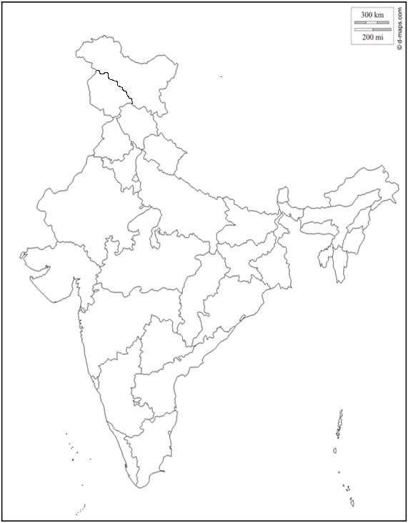

ROLL NO:
CLASS:

ROLL NO:
CLASS:
